Assignment 1

CCSW321 – WEB DEVELOPMENT

Waad Ghassan Mnyawi-2110069

Images of pages:

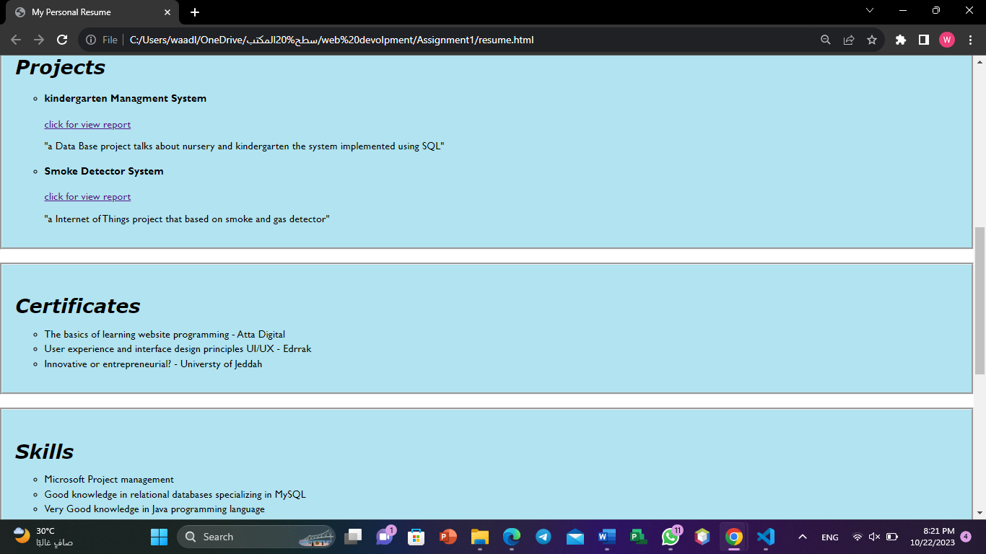صورة تحتوي على نص, لقطة شاشة, برمجيات, أيقونة الحاسوب

تم إنشاء الوصف تلقائياً

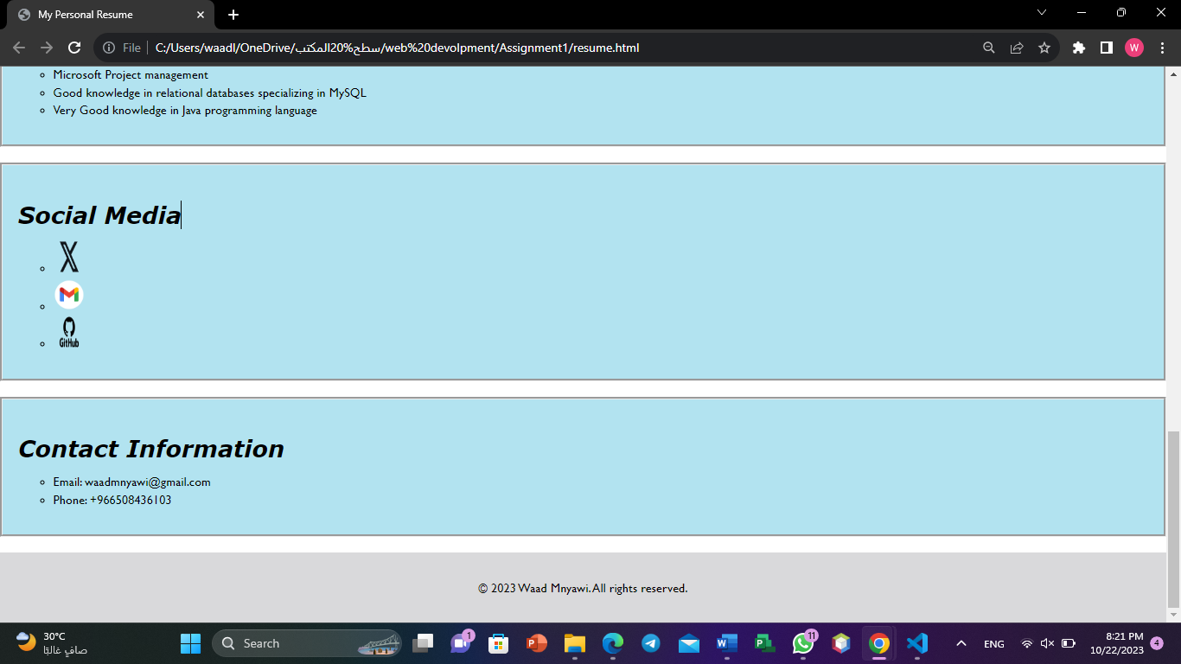

Code (HTML):

<!DOCTYPE html>

<html lang="en">

<head>

  <meta charset="UTF-8">

  <meta name="viewport" content="width=device-width, initial-scale=1.0">

  <title>My Personal Resume</title>

  <link rel="stylesheet" href="style.css">

</head>

<body>

  <ul class="navbar">

    <li><a href="#objectives">Objectives</a></li>

    <li><a href="#education">Education</a></li>

    <li><a href="#projects">Projects</a></li>

    <li><a href="#skill">Skills</a></li>

    <li><a href="#certificates">Certificates</a></li>

    <li><a href="#social-media">Social Media</a></li>

  </ul>

  <header>

    <h1>Waad Ghassan Mnyawi</h1>

    <img src="user.png" alt="user pic">

  </header>

  <section id="objectives">

    <h2>Objectives</h2>

    <p>My goal as Software Engreeing is to achive academic excellence

      and gain knowledge in the field of programming and Software Engreeing

      I would like to be able to solve complex challenges and contribute to

      the creation of high quality and reliable software. I also seek my network

      of contacts participating in group projects to enhance my interactivity

      and encourage communication.</p>

  </section>

  <section id="education">

    <h2>Education</h2>

       <p>Bachelor of Software Engreeing</p>

       <p>University of Jeddah , Jeddah , Saudi Arabia</p>

       <p>Expected Graduation Date: December 2024</p>

  </section>

  <section id="projects">

    <h2>Projects</h2>

    <ul>

      <li><h4>kindergarten Managment System</h4>

        <a href="Kindergarten.pdf">click for view report</a>

        <p>"a Data Base project talks about nursery and kindergarten the system implemented using SQL"</p>

      </li>

      <li><h4>Smoke Detector System</h4><a href="smoke detctor.pdf">click for view report</a>

        <p>"a Internet of Things project that based on smoke and gas detector"</p>

      </li>

    </ul>

  </section>

  <section id="certificates">

    <h2>Certificates</h2>

    <ul>

      <li>The basics of learning website programming - Atta Digital</li>

      <li>User experience and interface design principles UI/UX - Edrrak</li>

      <li>Innovative or entrepreneurial? - Universty of Jeddah</li>

    </ul>

  </section>

  <section id="skill">

    <h2>Skills</h2>

    <ul>

      <li>Microsoft Project management</li>

      <li>Good knowledge in relational databases specializing in MySQL</li>

      <li>Very Good knowledge in Java programming language</li>

    </ul>

  </section>

  <section id="social-media">

    <h2>Social Media</h2>

    <ul>

      <li><a href="https://www.twitter.com"><img src="x.png" alt="X"></a></li>

      <li><a href="mailto:waadmnyawi@gmail.com"><img src="gmail.png" alt="Gmail"></a></li>

      <li><a href="https://github.com/WaadMnyawi"><img src="github.png" alt="GitHub"></a></li>

    </ul>

  </section>

  <section id="contact">

    <h2>Contact Information</h2>

    <ul>

      <li>Email: waadmnyawi@gmail.com</li>

      <li>Phone: +966508436103</li>

    </ul>

  </section>

  <footer>

    <p>&copy; 2023 Waad Mnyawi. All rights reserved.</p>

  </footer>

</body>

</html>

Code (CSS):

body {

  display: grid;

  grid-template-rows: auto 1fr auto;

  min-height: 100vh;

  margin: 0;

  padding: 0;

}

header {

  text-align: center;

  padding: 20px;

  background-color: #f2f2f2;

}

header h1 {

  margin: 0;

}

header img {

  max-width: 150px;

  margin-top: 10px;

  height: 100px;

  width :120px

}

.navbar {

  display: flex;

  justify-content: center;

  align-items: center;

  background-color: #f2f2f2;

  padding: 10px 0;

  border-style: none;

}

.navbar ul {

  display: flex;

  margin: 0;

  padding: 0;

}

.navbar li {

  margin: 0 10px;

  list-style-type: none;

  font-family: 'Gill Sans', 'Gill Sans MT', Calibri, 'Trebuchet MS', sans-serif;

}

.navbar a {

  color: #333;

  text-decoration: none;

  font-weight: bold;

}

.navbar a:hover {

  color: #747474;

}

  header h1 {

    font-size: 45px;

    font-family: 'Gill Sans', 'Gill Sans MT', Calibri, 'Trebuchet MS', sans-serif;

    margin-bottom: 10px;

  }

  section {

    padding: 20px;

    margin-bottom: 20px;

    font-family: 'Gill Sans', 'Gill Sans MT', Calibri, 'Trebuchet MS', sans-serif;

    color: black;

    border-style: groove;

    background-color: #b2e3f0;

  }

  section h2 {

    font-size: 30px;

    margin-bottom: 10px;

    font-weight:bolder;

    font-style: oblique;

    font-family: Verdana, Geneva, Tahoma, sans-serif;

  }

  ul {

    list-style-type:circle;

    margin-left: 5px;

  }

  li {

    margin-bottom: 5px;

  }

  img {

  width: 40px;

  height: 40px;

  }

  footer {

    text-align: center;

    font-family: 'Gill Sans', 'Gill Sans MT', Calibri, 'Trebuchet MS', sans-serif;

    padding: 20px 0;

    background-color: #d9d9db;

    color: #000000;

  }

  /\* 576px \*/

@media (max-width: 576px) {

  header {

    padding: 20px 0;

  }

  img {

    max-width: 150px;

  }

  section {

    padding: 10px;

    margin-bottom: 10px;

  }

  section h2 {

    font-size: 20px;

  }

  ul {

    margin-left: 10px;

  }

  footer {

    padding: 10px 0;

  }

}

/\*  577px x 768px \*/

@media (min-width: 577px) and (max-width: 768px) {

  header {

    padding: 30px 0;

  }

  img {

    max-width: 180px;

  }

  section {

    padding: 15px;

    margin-bottom: 15px;

  }

  section h2 {

    font-size: 22px;

  }

  footer {

    padding: 15px 0;

  }

}

/\* 769px x 992px \*/

@media (min-width: 769px) and (max-width: 992px) {

  header {

    padding: 35px 0;

  }

  img {

    max-width: 190px;

  }

  section {

    padding: 18px;

    margin-bottom: 18px;

  }

  section h2 {

    font-size: 23px;

  }

  footer {

    padding: 18px 0;

  }

}

HTML Validation:

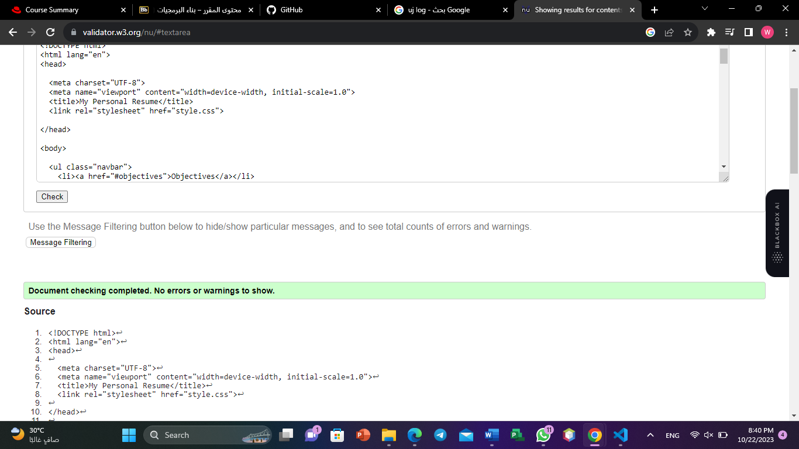

CSS validation:

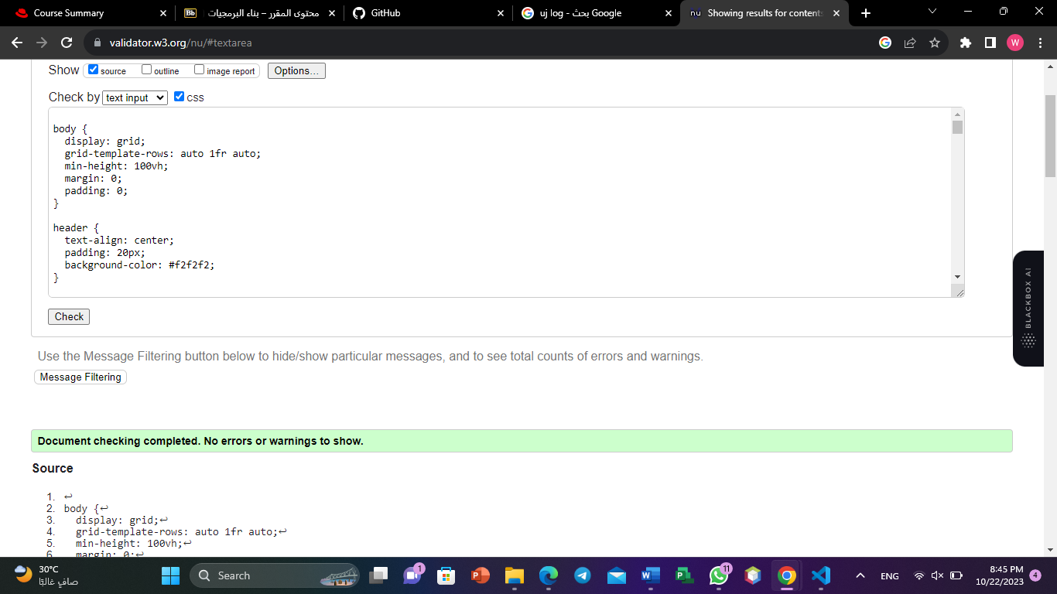

صورة تحتوي على نص, لقطة شاشة, برمجيات, برامج الوسائط المتعددة

تم إنشاء الوصف تلقائياً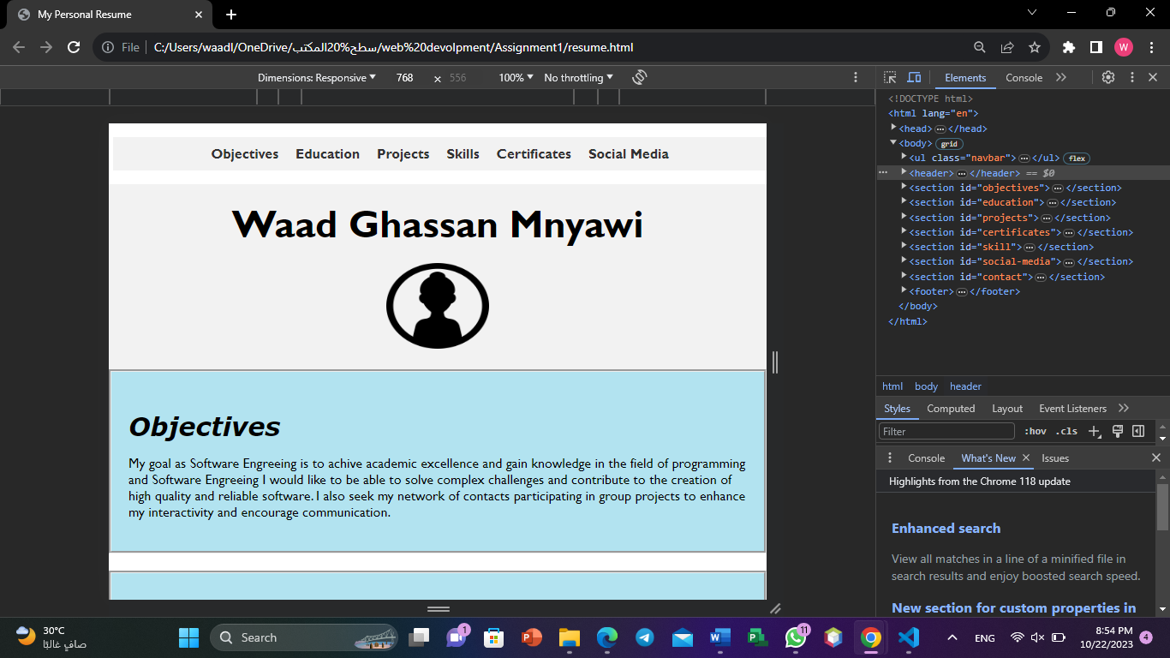Display at other browser sizes:

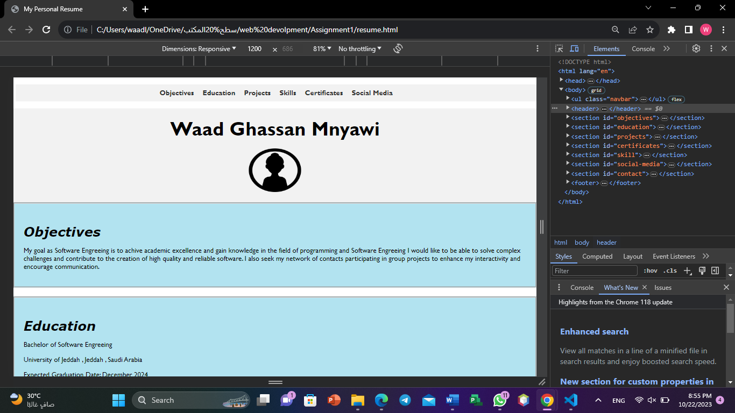

GitHub:

<https://github.com/WaadMnyawi/presonal-resume.git>